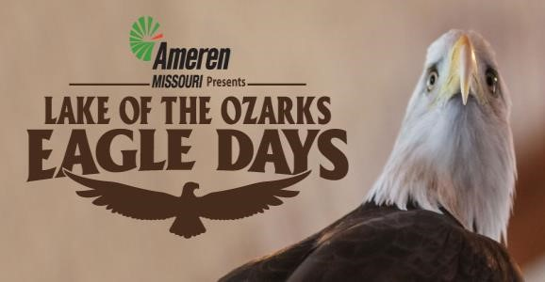

Sponsorship Opportunities

The Lake Area Chamber of Commerce, Missouri Master Naturalist Lake of the Ozarks Chapter, The Lake of the Ozarks Convention & Visitor Bureau, Osage National Golf Resort and Facelift Design+Print present the Ameren Missouri’s 2021 Lake of the Ozarks Eagle Days. The 2021 event dates are Saturday, January 9th from 9:00 am – 5:30 pm and Sunday, January 10th from 10:00 am – 4:30 pm.

Highlights of the program include live eagles from the World Bird Sanctuary with a naturalist on hand to answer questions at Osage National Golf Resort. Interactive exhibits, vendors, photo contest, and a coloring contest will take place at the School of the Osage Heritage Elementary, along with two live bird programs from the Dickerson Park Zoo, including American Bald Eagle and Owls of Missouri. Live eagle viewing will be at Willmore Lodge and below Bagnell Dam at the Missouri Department of Conservation Osage River Access, where the Missouri Master Naturalist - Lake of the Ozarks Chapter will be available to answer questions and point your eyes in the right direction for possible siting along with free hot chocolate.

This event is FREE and open to the public thanks to our generous sponsors. There is cost associated with securing the bird presentations from World Bird Sanctuary and Dickerson Park Zoo and we need your help. We invite you to get involved in this fun, family-friendly educational event that will be enjoyed by over a thousand visitors and residents. We are providing different levels of sponsorship for anyone wishing to help us meet the budget needs of the Lake of the Ozarks Eagle Days.

*Ameren Missouri’s 2021 Lake of the Ozarks Eagle Days is planning to proceed and will be following all state and county guidelines concerning public health and safety. However, things may change according to current conditions and announcements will be made, as necessary.

$500 Platinum Sponsor
Business name mentioned on all radio advertising promoting the event
Business logo on 5,000 post cards distributed to promote the event
Business logo on print advertising and press releases promoting the event
Business logo on the cover of 1,000 eagle day programs distributed to attendees
Business logo listed on the event website with link: www.lakeoftheozarkseagledays.com
Business logo on event signage at all four venues during the event
Complimentary exhibit space with table and two chairs at venues of choice (location may be adjusted at the discretion of committee)
$200 Gold Sponsor
Business name in press releases promoting the event
Business logo in 1,000 eagle day programs distributed to attendees
Business logo listed on the event website with link: www.lakeoftheozarkseagledays.com
Business logo on event signage at all four venues during the event
Complimentary exhibit space with table and two chairs at two venues of choice (location may be adjusted at the discretion of committee)
$100 Silver Sponsor
Business name in press releases promoting the event
Business name in 1,000 eagle day programs distributed to attendees
Business name listed on the event website with link: www.lakeoftheozarkseagledays.com Business name on event signage at all four venues during the event
$50 Bronze Sponsor
Business name in 1,000 eagle day programs distributed to attendees
Business name listed on the event website with link: www.lakeoftheozarkseagledays.com
Business name on event signage at all four venues during the event
------------------------------------------------------------------------------------------------------------------------------------------------------
Business Name: __________________________________________ Contact Name: __________________________
Address: _______________________________ City: _____________________ State: _______ Zip: ______________
Web Address: __________________________________ Business Phone: _______________ Cell: _______________

Circle Sponsorship Level: $500 Platinum $200 Gold $100 Silver $50 Bronze

Ameren Missouri’s Lake of the Ozarks Eagle Days • PO Box 1498 • Osage Beach • MO 65065 • (573) 348-1599

